E – COMMERCE SALES ANALYSIS - PROJECT

Q1. Which productline generates the highest and lowest revenue?
Query- select productline,round(sum(sales),1) as total_revenue
from sales_data_sample
group by productline
order by total_revenue descselect productline

RESULT:-
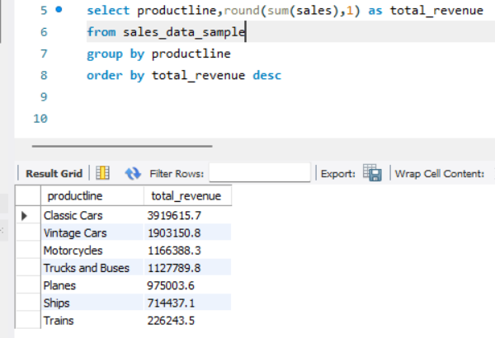

BUSINESS RECOMMENDATION :-
Product Line | Action
Classic Cars | Invest More
Trains | Review & Potentially Reduce Investment
Mid-performing Product lines | Maintain and Optimize

Executive Insight
Classic Cars is the revenue engine of the business and should receive additional investment in inventory, marketing, and product expansion. Trains contribute the least revenue and should be reviewed for demand, profitability, and strategic value before allocating further resources. Resources may be reallocated from Trains to higher-performing categories such as Classic Cars to maximize overall revenue growth.

Q2. Which country/territory generates the highest sales?
Query :- select country,territory,round(sum(sales),1) as total_sales
from sales_data_sample
group by country,territory
order by total_sales desc;
RESULT:-
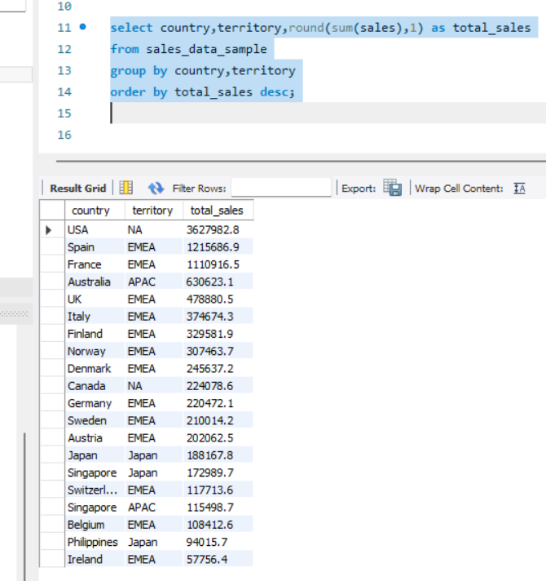
Business Insight: Market Expansion
After running the query, USA emerges as the highest-sales country.
Insight 1: Protect Your Core Market
- USA is the primary revenue driver.
- Maintain strong inventory levels.
- Launch loyalty programs and premium offerings.
- Focus on customer retention because losing customers here would significantly impact revenue.
Insight 2: Expansion Opportunities
Look at countries ranked 2nd–5th.
If countries such as:
- France
- Australia
- UK
- Spain
are generating substantial sales despite smaller customer bases, they may have untapped potential.
Insight 3: Use Revenue per Customer
A better expansion metric is:
SELECT
COUNTRY,
COUNT(DISTINCT CUSTOMERNAME) AS CUSTOMERS,
ROUND(SUM(SALES),2) AS TOTAL_SALES,
ROUND(SUM(SALES)/COUNT(DISTINCT CUSTOMERNAME),2) AS SALES_PER_CUSTOMER
FROM sales_data_sample
GROUP BY COUNTRY
ORDER BY SALES_PER_CUSTOMER DESC;
A country with:
- Few customers
- High sales per customer
indicates strong demand and a good candidate for expansion.
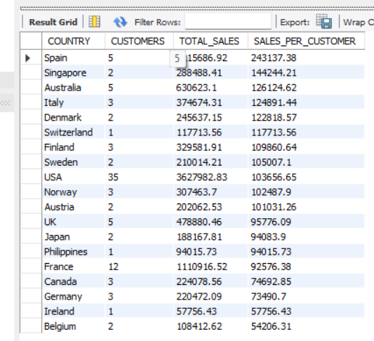

Executive-Level Recommendation
The highest-selling country should remain the company's primary focus for customer retention and revenue stability. For expansion, management should target countries with strong sales performance but relatively smaller customer bases, as these markets demonstrate proven demand and offer significant growth potential through increased marketing, distribution, and customer acquisition efforts.

Q3.what is the impact of dealsize (small/medium/large) on total revenue which segment contributes the most ?

QUERY :-
select dealsize,sum(sales) as revenue,
round(sum(sales)/(select sum(sales) from sales_data_sample)*100,2) as contribution_prcnt
from sales_data_sample
group by dealsize
ORDER BY REVENUE DESC;

RESULT- 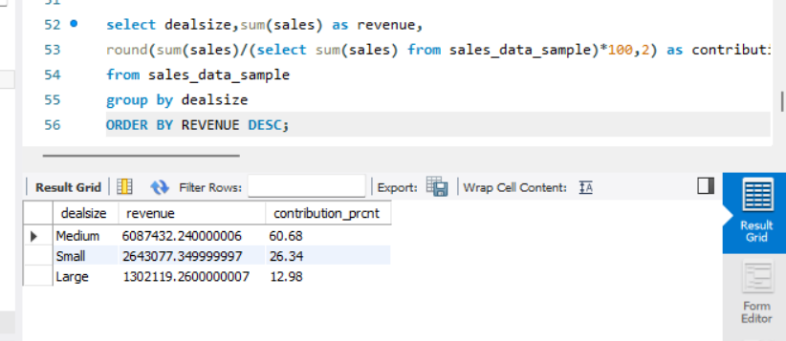

Business Insights
1. Medium Clients Are the Sweet Spot
- They generate the highest share of revenue.
- Revenue is distributed across many customers, reducing dependence on a handful of large accounts.
- They provide a balance between volume and deal value.
Recommendation: Make medium-sized clients the primary target segment.

2. Upsell Medium → Large
Since medium clients already spend significantly:
- Offer premium product bundles.
- Create loyalty programs.
- Assign dedicated account managers to top medium clients.
- Encourage larger order quantities.
Goal: Convert high-performing medium customers into large accounts.

3. Small Clients as a Pipeline
Small deals contribute over 26% of revenue, which is still meaningful.
These customers can be viewed as:
- Future medium clients
- A source of recurring revenue
- A way to diversify risk
Recommendation: Continue acquiring small customers, but focus on growing them over time.

4. Large Segment Needs Investigation
Large deals contribute less than expected.
Possible reasons:
- Not enough enterprise customers.
- Weak penetration in high-value accounts.
- Sales team focuses more on medium clients.
Recommendation: Analyze large-deal win rates and identify barriers to acquiring more enterprise-level customers.

Executive Summary
Medium-sized deals contribute 60.68% of total revenue, making them the most important customer segment for the business. The sales team should prioritize acquiring and retaining medium-sized clients while implementing upselling strategies to convert them into large accounts. Small clients should be nurtured as a future growth pipeline, while the relatively low contribution from large deals indicates an opportunity to strengthen enterprise customer acquisition efforts.

Q4.What is the year over year sales trend -is the business growing or declining?

Query :-

WITH yearly_sales AS (
SELECT
YEAR_ID,
SUM(SALES) AS TOTAL_REVENUE
FROM sales_data_sample
GROUP BY YEAR_ID
order by year_id asc

)
SELECT
YEAR_ID,
ROUND(TOTAL_REVENUE,2) AS TOTAL_REVENUE,
ROUND(
((TOTAL_REVENUE -
LAG(TOTAL_REVENUE) OVER(ORDER BY YEAR_ID))
/
LAG(TOTAL_REVENUE) OVER(ORDER BY YEAR_ID)
) * 100,
2) AS GROWTH_PERCENT
FROM yearly_sales;

Result:-

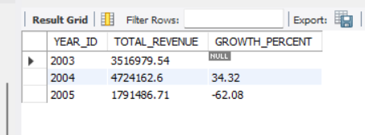

BUSINESS INSIGHTS:-
Overall Company Health & Growth Trajectory
The company appears to be in a healthy growth phase. Revenue increased from $3.52M in 2003 to $4.72M in 2004, showing a strong 34.32% growth rate. This indicates that the company's products are performing well in the market and customer demand is increasing.
A major strength of the business is that Classic Cars generate the highest revenue, while Medium-sized deals contribute more than 60% of total sales. This means the company is not dependent on just a few large customers and has a stable revenue base.
The business also has opportunities to grow further by:
- Investing more in high-performing product lines like Classic Cars.
- Expanding in strong-performing countries and territories.
- Converting medium-sized customers into larger accounts.
Although revenue appears lower in 2005, the dataset only contains partial-year data, so it would be inaccurate to conclude that the business is declining.

Q5. Who are the top 10 customers generating the highest revenue?
QUERY:-
with cte as (
select CUSTOMERNAME,ROUND(SUM(SALES),1) AS TOTAL_SALES,COUNTRY,TERRITORY,COUNT(distinct ORDERNUMBER) AS TOTALORDERS,
ROUND(
SUM(SALES) / COUNT(DISTINCT ORDERNUMBER),
0
) AS AVG_ORDER_VALUE
from sales_data_sample
group by CUSTOMERNAME,COUNTRY,TERRITORY
ORDER BY TOTAL_SALES DESC
LIMIT 10 )
select *,round(total_sales*100/(select sum(sales) from sales_data_sample),1) as contributionprcnt
from cte;
RESULT:-
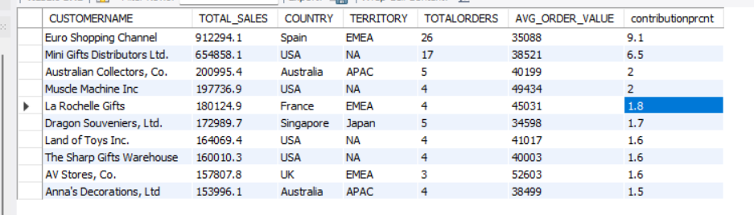
Customer Analysis – Key Business Insights
Strategic Customers
The analysis shows that Euro Shopping Channel is the company's most valuable customer, contributing 9.1% of total revenue. Similarly, Mini Gifts Distributors Ltd. contributes 6.5% of total revenue. Since these customers generate a significant share of sales, maintaining strong relationships with them should be a priority.
Importance of Repeat Customers
Euro Shopping Channel generated over $912K in revenue through 26 orders, indicating that repeat purchases play a major role in revenue generation. This suggests that retaining existing customers can be as important as acquiring new ones.
High-Value Customer Segment
Customers such as AV Stores, Muscle Machine Inc., and La Rochelle Gifts have the highest average order values. Although they place fewer orders, each transaction generates substantial revenue. This indicates an opportunity to target more customers with similar purchasing behavior.
Geographic Opportunities
Most of the top-performing customers are located in the USA and EMEA region. This suggests that these markets have strong demand and should be considered key areas for future expansion and sales efforts.
Revenue Stability
The top 10 customers contribute approximately 29.4% of total revenue. This indicates that the company is not overly dependent on a small number of customers, which reduces business risk and creates a more stable revenue stream.
Conclusion
Overall, the company has a healthy customer base with a good balance between high-value accounts and repeat customers. Future growth can be achieved by strengthening relationships with key customers, attracting more high-value buyers, and expanding further in strong-performing markets such as the USA and Europe

Q6.what percentage of total orders are “disputed” or “cancelled” and in which product line or country are they most common ?

QUERY:- overall percentage of disputed/cancelled orders

select(
select
count(distinct ordernumber) as problem_orders
from sales_data_sample
where status in ('cancelled','disputed')
)/count( distinct ordernumber)*100 as prcnt_problm_orders
from sales_data_sample;

RESULT:-
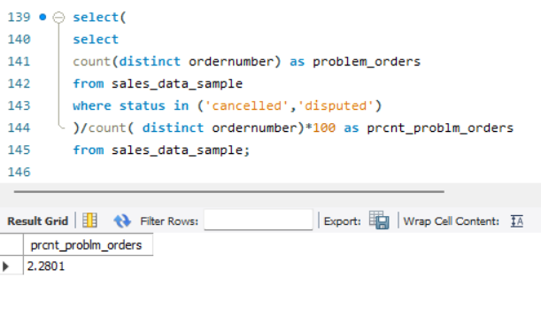

QUERY 2 :- Which productline are they common the most?

SELECT
PRODUCTLINE,
COUNT(DISTINCT ORDERNUMBER) AS PROBLEM_ORDERS
FROM sales_data_sample
WHERE STATUS IN ('Cancelled','Disputed')
GROUP BY PRODUCTLINE
ORDER BY PROBLEM_ORDERS DESC;

RESULT:-

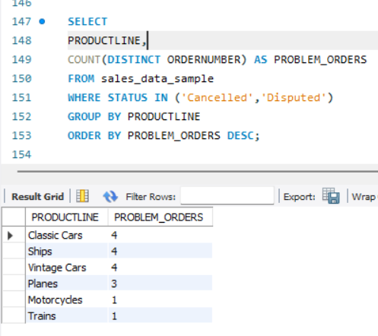

QUERY 3:- WHICH COUNTRY ARE THEY MOST COMMON?
SELECT
COUNTRY,
COUNT(DISTINCT ORDERNUMBER) AS PROBLEM_ORDERS
FROM sales_data_sample
WHERE STATUS IN ('Cancelled','Disputed')
GROUP BY COUNTRY
ORDER BY PROBLEM_ORDERS DESC;

RESULT:-
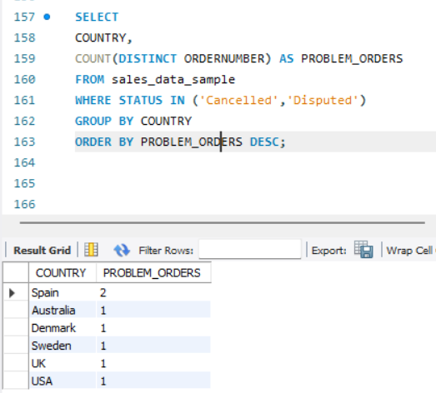

BUSINESS INSIGHTS:-
Order Cancellation & Dispute Analysis
Overall Finding
Only 2.28% of total orders were cancelled or disputed, indicating that the business has a strong order fulfillment process and low operational risk.
Product Line Insights
- Classic Cars, Ships, and Vintage Cars recorded the highest number of problematic orders (4 each).
- Since Classic Cars is also the company's top revenue-generating product line, reducing order issues in this category could have a direct positive impact on revenue and customer satisfaction.
Geographic Insights
- Spain reported the highest number of cancelled/disputed orders.
- While the issue volume is not alarming, Spain should be reviewed to identify possible logistics, delivery, or customer service challenges.
Business Recommendation
- Prioritize investigation of issues within Classic Cars, Ships, and Vintage Cars.
- Review operational performance in Spain.
- Maintain current fulfillment standards, as the overall dispute/cancellation rate remains very low.
Executive Conclusion
The company demonstrates strong operational performance, with only 2.28% of orders experiencing disputes or cancellations. Most issues are concentrated in Classic Cars, Ships, Vintage Cars, and the Spanish market, making these the key areas for process improvement and risk reduction.

Q7. How does the average order value compare across territories (EMEA, APAC, NA, Japan) which territory generates higher value per order?
QUERY:-
select round(sum(sales),2) as total_revenue,count( distinct ordernumber) as total_orders,territory,round(
sum(sales) /count(distinct ordernumber),2) as avgordervalue
from sales_data_sample
group by territory
order by avgordervalue desc ;

RESULT:-
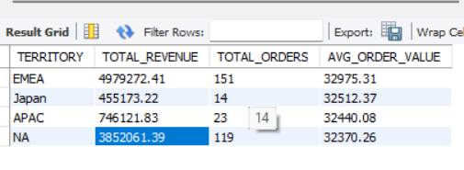

BUSINESS RECOMMENDATIONS:-

EMEA: Strongest Performing Market
EMEA generates the highest revenue ($4.98M) and the highest number of orders (151) while maintaining an average order value comparable to other regions.
Insight:
The region's success is driven by a large customer base and strong order volume rather than higher spending per order. This indicates strong market penetration and customer demand.
Recommendation:
Continue investing in customer retention and relationship management, as EMEA is currently the company's most important revenue-generating market.

North America (NA): Stable Growth Market
North America is the second-largest contributor in terms of both revenue ($3.85M) and orders (119).
Insight:
The region shows healthy demand and a well-established customer base. Although its average order value is slightly lower than other territories, the difference is negligible.
Recommendation:
Focus on upselling existing customers and increasing repeat purchases to drive additional growth.

APAC & Japan: Untapped Growth Opportunity
APAC and Japan generate significantly fewer orders and lower total revenue, but their average order values are almost identical to EMEA and NA.
Insight:
Customers in these regions spend roughly the same amount per order as customers in larger markets. The challenge is not customer spending behavior but the relatively low number of transactions.
Recommendation:
Increase marketing efforts, customer acquisition initiatives, and market presence in APAC and Japan. Since spending per order is already strong, expanding the customer base could significantly increase revenue.

Executive Conclusion
The analysis shows that revenue differences across territories are primarily driven by order volume rather than order value. EMEA and North America are mature, high-performing markets with strong customer bases, while APAC and Japan represent growth opportunities where customer spending is already healthy but market penetration remains limited. Future growth should focus on maintaining market leadership in EMEA and NA while investing in customer acquisition and expansion efforts in APAC and Japan.

